PARISH NEWS
The Deverills & Crockerton

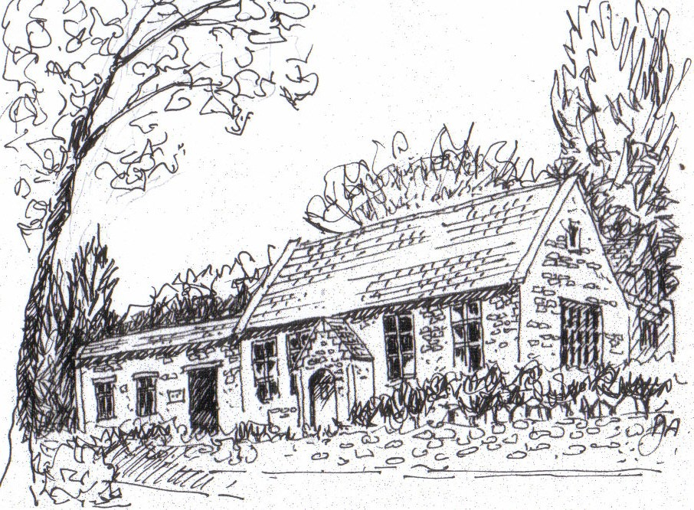

Crockerton School
by Pat Armstrong

September 2009

Look inside for local information

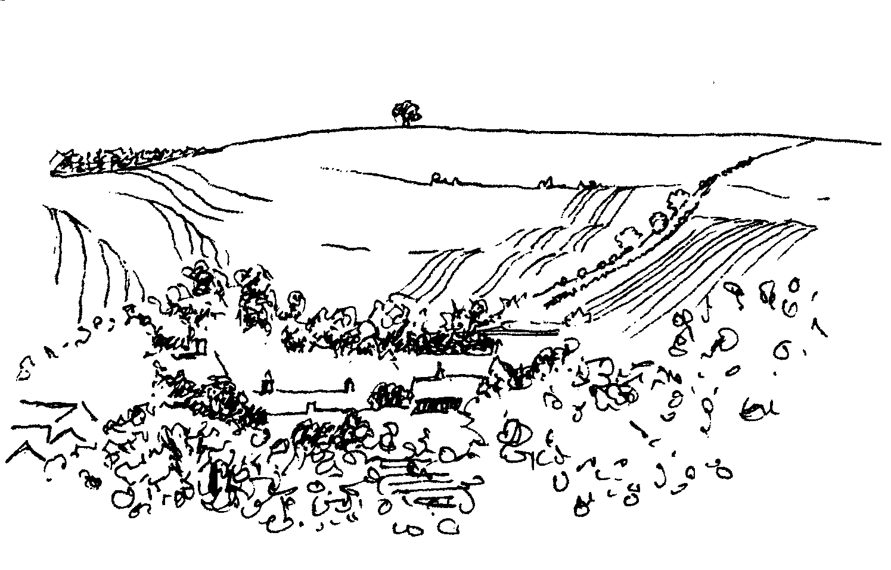
-2-


Fight for Sight Charity Fair
Thursday 1st October 10.00 am - 3.30 pm

Rye Hill Barn, Longbridge Deverill, BA12 7DE (Maiden Bradley road)
Entrance £3 - Lots of lovely stalls, gifts for all the family
Bring friends, enjoy coffee & delicious snacks by Sandy Parrish
All profits go to research into debilitating eye diseases
Further information at www.fightforsight.org.uk
MacMillan Cancer Support
World’s Biggest Coffee Morning
Friday 25th September 10.00 am – 12.00 noon
Come and support us at Lakeside Garden Centre
Cakes, Raffle, Tombola etc
Donations for stalls gratefully received
Deverill Valley Clarinet Quintet Concert
Saturday 17th October 8.00 pm Longbridge Church
Tickets £10.00 phone Julian Wiltshire 844152
Claire Johnson (clarinet), Magnus Johnston (violin), Sarah Bayley (violin),
Polly Wiltshire (viola) and Harriet Wiltshire (cello)
We will celebrate the most exquisite music written for clarinet,
beautiful Quintets by Mozart and Brahms and Eilean Shona by Holbrooke
Pre - concert supper 6.30 pm at Longbridge Village Hall
Tickets £10.00 (with glass of wine) phone Janet Budgen 218203
Cheques: PCC Deverills & Horningsham - profit Deverill Churches Fabric Fund Come and enjoy a delicious meal and the sound of golden warmth and
mellowness at this Autumn concert.

Fight for Sight Charity Fair
Thursday 1st October 10.00 am - 3.30 pm

Rye Hill Barn, Longbridge Deverill, BA12 7DE (Maiden Bradley road)
Entrance £3 - Lots of lovely stalls, gifts for all the family
Bring friends, enjoy coffee & delicious snacks by Sandy Parrish
All profits go to research into debilitating eye diseases
Further information at www.fightforsight.org.uk

SATURDAY 12TH SEPTEMBER
SUPPORT
THE WILTSHIRE
HISTORIC CHURCHES TRUST
TO TAKE PART
PLEASE CONTACT
JUDY MUNRO 844385



Coffee, Cards and Chat
Come and enjoy looking at the new range of cards,
ribbons, wrapping paper, and other exciting items
displayed by John and Maddie Goodden
in the Upper Deverills Village Hall on Thursday 19th February
between 10.30 and 12.00 noon - everyone is welcome
Donations will be made to the hall and the church



-3-

The Rector writes:
How can it be that September is here already? The academic year starts again; for all pupils, that means a new school or a new class. School leavers may be preparing for courses at college or university or looking forward to that very important first job.
For us in this Benefice, September signals a busy few months, with the many special services / events associated with this time of year. The first of these is Back to Church Sunday, which will be held on 27th September. Preparations for that event have set me thinking about why it is that patterns of behaviour change. Why do people stop attending church? The research I have read, particularly a report published in 2005, makes thought-provoking reading. One of the most challenging and profound comments came from someone in the Midlands, who wrote: It is a myth to say that the people of this country have rejected Christianity; they simply haven’t been told enough about it to either accept or reject it.
To read some of the reasons that cause people to avoid church was heart-breaking. Misunderstandings figured highly, dislike of parts of the liturgy, lack of pastoral care, the watering-down of the gospel, other things happening on Sundays and many other reasons besides. Hopefully, Back to Church Sunday will provide an opportunity to look again at some of those issues, both for those of us who are church members and those who are no longer. It is always a privilege to have conversations and to hear the stories, which you have to tell, even when they are critical of the past.
I hope you will think about church, whether you attend regularly or not. If you don’t attend, why not give it a try sometime? If you do, what is it that you value and find sustaining to help you through each week?
My colleagues and I hope to see you on 27th September. In the meantime, may God’s blessing be with you all.
Norma Payne
PS During the autumn, look out for details of the Harvest Festivals, All Saints, All Souls (when we especially remember those who have died during the past year), and Remembrance Sunday to name but a few.
Back-to-Church Sunday
On Sunday 27th September 10.30 am. Do please come and join us as we celebrate the Patronal Festival of St. Michael's Church, Brixton Deverill. The service will last about an hour and refreshments will be served afterwards.
Church Security
Recently there have been two cases of handbags being stolen from Kingston church and some other petty thieving. Please be careful to safeguard your belongings when visiting all our churches, keep them with you or safely locked in your car. If you see anyone acting suspiciously near any of the churches please make a note of their description and call the police (0845 408 7000).

-4-

Upper Deverills Parish Council - New Clerk
After 5 years Jacqueline Smith has retired as Clerk to UDPC. The Council would like to take this opportunity to thank her for all she has done for the Parish, and to wish her well in the future. We would like to welcome Sarah Jeffries who has taken over the position of Clerk. She has been the Clerk for Maiden Bradley with Yarnfield Parish Council for 4 years and is also Clerk to Horningsham Parish Council. She is qualified in Local Council Administration and an Associate Member of the Institute of Local Council Managers. She also works as Clerical Assistant at Horningsham Primary School. She is can be contacted 10.00 am to 4.00 pm Monday to Thursday. Her contact details are: 9 Beech Grove, Warminster, Wiltshire BA12 0AB
Tel.: 01985 213436 Mb: 07513 459353 Email: upperdeverillspc@02.co.uk
The date of our next meeting is Wednesday 9th September in the Upper Deverills Village Hall; members of the public are very welcome to attend.
A303 Closure
Some of you may already have received information on the planned repair works for the A303 between Mere and Willoughby Hedge; but for those who have not the details are as follows:
- 16th Nov – 14th Dec 2009: Full overnight closure between 10.00 pm - 6.00 am
- 14th Dec 2009 – 18th Jan 2010: No activity planned.
- 18th Jan – 15th Feb 2010: Lane closures (possible full closure) 7.30 pm - 6.00 am.
- 15th Feb – 15th Mar 2010: Full closure.
- 16th Mar 2010: Work complete.
The official diversion routes that will be put in place for:
Night Time Closures
- Light vehicles (east & westbound) use the A350 & B3081 through Gillingham.
- HGVs (east bound) leave the A303 at the Podimore Roundabout then via A37 (to Shepton Mallett), A361 (to Frome), A36 (via Warminster) back onto the A303 at Deptford Interchange (Wylye).
- HGVs (westbound) the same route as eastbound but in reverse.
24hr+ Closures
- All eastbound traffic leave the A303 at the Podimore Roundabout via A37, A361 & A36, except high loads which will leave the A303 at Sparkford and follow the A359 onto the A361.
- All westbound traffic leave the A303 at Furze Hedge and follow the A350 to Shaftesbury, then the B3081 via Gillingham back onto the A303.
A meeting is being held between the Upper Deverills and Longbridge Deverill & Crockerton Parish Councils (+ Traffic Advisory Group) with Wiltshire County Traffic Representatives, InterRoute (Highways Agency Agent) and the Police. We will express our concerns over the likely increase in traffic that will be experienced on the B3095 and Hindon Road during closures/restrictions on the A303. We will ask for measures to be implemented to minimise the increase in traffic and ensure any increases will be safely managed, not impacting upon the safety of drivers or residents.
Ranald Blue 841374

-5-

The Cast on Club
Norma has requested help with her story telling to children, in the form of knitted dolls to represent the people in the stories she tells. The first meeting of the Cast on Club will take place on Thursday 10th September at 10.30 am at Diana Abbott’s home, Uppington House, 29 The Marsh. We propose to meet once a fortnight. Everyone is welcome whether you have knitting skills or not, help will be at hand! The pattern is simple. If you have any double knitting yarn and a pair of 3mm knitting needles, please bring them along. We look forward to seeing you. If you have any queries or need directions to Diana’s house please call Judy Munro 844385.
Thank You
To everyone who made the Jazz concert at Brixton such an enjoyable evening. Particularly I must mention Johnny and Pony Burridge who generously let us into the Manor House for a wonderful supper organised by Janet Budgen, ably helped by Sylvia Titt and Julie Walder; John Budgen and Pat Armstrong who managed the wine so efficiently (keeping beady eyes open for the second glasses!); and last but by no means least ALL of you who helped and supported the occasion brilliantly. We raised £1,263.00 net for the church Fabric Fund and were nominated by the excellent 4-4 Jazz Band "their best gig of the year". Who could ask for more?
Mary Stewart Cox
Longbridge Deverill Village Hall
A full house enjoyed a very lively Quiz Night in July which raised almost £100, this will go towards the maintenance of the Hall. A big thank you to our quiz master ‘Bamber Gascoigne’ AKA Guy Ratcliffe whose questions ranged from, “What are the names of the Manchester United players who have worn the number 7 shirt” to “How many Prime Ministers of England have been assassinated?” The most popular answer to this one was “not enough!”. Many thanks to everyone who came along and supported us at this event. If anyone is interested in joining the hall committee they would be most welcome to join us, please call Julie Reed 840655.
Our next events are on:
Saturday 10th October - Harvest Supper
Saturday 12th December - Community Carols
Upper Deverills Village Hall
We have an exciting programme of events for the autumn and winter outlined below so please note them in your diaries and come along and enjoy them.
Friday 2nd October - Film Night
Saturday 31st October - Halloween Harvest Supper
Remembrance Sunday 8th November - Curry Lunch
Friday 13th November - Quiz Night
Sunday 20th December - Carol Service

-6-

Wild Elephant Conservation in Thailand
Exhibition & Sale of pictures painted by elephants
presented by Belinda Stewart-Cox
at the Bull Mill Crockerton
Saturday & Sunday 5th & 6th September
10.00 am - 4.00pm
Weekdays by appointment call 840877 or 212716
All profits to the Elephant Conservation Network
Salisbury Theatre Club Trips
Monday 21st September
The Lady in the Van by Alan Bennett
Monday 19th October
After Miss Julie by Patrick Marber
Monday 16th November
Arsenic & Old Lace by Joseph Kesselring
The cost is £17.00: theatre seat £12.00 and coach trip £5.00
Booking and payment in advance to Mary Stewart Cox Tel 840877
Longmead, Brixton Deverill, Warminster BA12 7EJ
Coach leaves Kingston Church 6.10 pm collects through the Deverills
Performances begin at 7.30 pm



Coffee Morning
In aid of Kampala Music School
Tuesday 13th October 10.30 am - 12.30 pm
At Frog Lane Farmhouse, 84 Sand Street
Ugandan hand made bead necklaces, earrings and bracelets, batik and banana leaf cards, bookmarks, Christmas cards
Tea, coffee and homemade cakes
Claire Johnson 840787
For the Elephant
Conservation
Network
JUNK (upwards) SALE
Thursday 10th September 10.30 am - 2.30 pm
At Long Mead, Brixton Deverill
Entrance £3.00 & Raffle
In aid of Elephant Conservation Network
Bring your friends for a cup of tea or coffee or
glass of wine and a lot of junk

-7-


Pre-school children & parents ‘Thursday’ group
Deverills Chamber Choir
Invites you to an informal concert
Friday 20th November at 7.30 pm
At Longbridge Deverill Church
Light refreshments - small donation appreciated
Come & listen to a variety of songs - you may be inspired to join us!
For more information please contact Claire Johnson 840787

We are re-opening on Thursday 3rd September from 10.00 - 11.30 am at Longbridge Deverill Village Hall. We are always looking forward to welcoming new parents/carers with children, under 5 years old, to join our happy group. For further details please contact Barbara on 844995 or Sylvia on 214825.
Save the Children Fund
Cream teas and open garden in aid of Save the Children will be held at Mill Farm House, Hill Deverill on Sunday 27th September between 3.00 – 6.00 pm. Do come and join us for an enjoyable and relaxing afternoon in the barn.
Anne Hurd
Deverill Valley & Crockerton Women's Institute
If you walked by Longbridge Deverill Village Hall one afternoon recently, you may have heard the joyful and melodious sounds of the Gospel Choir Workshop. Forty eight WI members sang under Jo Sercombe's leadership. They gave her a standing ovation at the end of the day for such a happy experience. This was one of many events open to members and non members taking place in Wiltshire. To find out more ring me or come to our next local meeting on Monday 14th September at 7.30 pm in Longbridge Deverill Village Hall, the talk will be on 'The Life and Times of Thomas Hardy' with a quiz 'Hardy's Wessex'.
Jill Russell 840209

Clippers & Windjammers
Great days of square rigged sailing ships in stories and pictures
Saturday 21st November in Codford Village Hall
Doors open 6.45 pm for a glass of wine,
Performance at 7.15 pm followed by supper
Information & Tickets £15 from Jane 840258 or Annie 840184
In aid of Hope & Homes for children and
Friends of Heytesbury, Knook & Tytherington Churches
-8-
SERVICES PARISH OF DEVERILLS & HORNINGSHAM
Contact the Clergy
Please contact Norma Payne (841321) or Di Britten (01373 832515) if anyone is housebound and would like communion or a visit at home;
or if someone is ill and needs our prayers; or to discuss any church matter.
Office administrator phone 210149 or email: office@cleyhill-team.org.uk

The Deverills & Horningsham Register
Ashes interred at Longbridge
Jenny Dancaster on Tuesday 4th August
Funeral at West Wilts Crematorium
Joan Evelyn (Paddy) Steptoe on Tuesday 11th August

Sunday Trinity 13
6th September Brixton 8.00 am Holy Communion 1662
Longbridge 10.30 am Commissioning Service*
Horningsham 6.30 pm Evensong
Sunday Trinity 14
13th September Kingston 10.30 am Holy Communion
Horningsham 11.15 am Holy Communion
Sunday Trinity 15
20th September Longbridge 10.30 am Holy Communion
Sunday Trinity 16
27th September Brixton 10.30 am Patronal Holy Communion**
Horningsham 11.15 am Morning Prayer
Kingston 6.00 pm Evening Prayer
Sunday Trinity 17
4th October Kingston 8.00 am Holy Communion 1662
Longbridge 10.30 am Morning Worship
Horningsham 6.30 pm Harvest Festival

*Commissioning Service for Carol Clough, Head Teacher of Crockerton School
** Back to Church Sunday

Tuesday, Wednesday, Thursday, Friday Longbridge 8.30 am Prayers
Wednesday Longbridge 10.15 am Holy Communion
Parish Prayer Group meeting - September
Deverills and Horningsham: Tuesday 8th September from 7.00 pm to 8.00 pm
at the Rectory, Longbridge, to pray particularly for our communities.

-9-

Ivy House St Denys Retreat Centre
A place for rest, refreshment and renewal
Thursday 10th September - Garden Quiet Day
To book and for more information please phone 214824
SERVICES PARISH OF CORSLEY & CHAPMANSLADE
Sunday Trinity 13
6th September Corsley 9.00 am Holy Communion
Sunday Trinity 14
13th September Chapmanslade 9.00 am Holy Communion
Temple 11.00 am Morning Prayer
Sunday Trinity 15
20th September Chapmanslade 9.00 am Holy Communion
Corsley 6.00 pm Prayer & Praise
Sunday Trinity 16
27th September Temple 9.00 am Holy Communion 1662
Corsley 10.30 am Parish Service
Sunday Trinity 17
4th October Corsley 9.00 am Holy Communion

Parish Prayer Group meeting - September
Corsley and Chapmanslade: Sunday 20th September at 6.00 pm in St. Margaret's Church, Corsley, after Prayer and Praise.

Church Cleaners for September
Kingston - Mrs Fagan & Mrs Mounde
Brixton – Mrs Lawson & Dr McBride
Longbridge - Monday 7th September 9.30 - 10.30 am - all helpers
Church Flower Arrangers for February
 | Kingston | Brixton | Longbridge
6th Sept | Mrs Goodden | Mrs Burridge | Mrs Young
13th Sept | Mrs Wiltshire | Lady Walker | Mrs Jackson
20th Sept | Mrs Wiltshire | Lady Walker | Mrs Jackson
27th Sept | Mrs Noonan | Mrs McDonald | Mrs Steptoe

-10-
Sowing SEEDS

Get your Stetson out and pull your Boots on!!!
It’s ‘The Crockerton ‘Hoedown’
Friday 18th September 6.00 - 8.00 pm
On the School ‘Rodeo’ Field
Join us for an evening of Western line dancing
BBQ & Refreshments, Western Boot Wang, Prizes: best dressed Cowboy/Cowgirl
Ride Brian - The Shetland Pony (Young ones only!)
Gun Alley, The ‘Stocks’, Raffle, Tombola, Face Painting & lots more!!!

Sowing SEEDS is a funding programme for local communities in an area comprising most of north and east Dorset and the Cranborne Chase and West Wiltshire Area of Outstanding Natural Beauty (AONB). We have £2.85M to spend on projects that are innovative and community led, benefit people in the area and:
Support rural businesses involving local products, services or skills; or
Provide increased opportunities for growth through the conservation and enhancement of the area’s natural and built environment; or
Develop opportunities to engender a sense of shared identity, leading to the development of community-based enterprise for sustainable economic growth.
What makes Sowing SEEDS unique is the Local Action Group (LAG). Anyone who lives or works in the area can become a LAG member, get involved with shaping the direction of the funding programme and have a fair and equitable say in which projects receive funding support. We need more members! The next LAG meeting will be at Durweston Village Hall on Tuesday 15th September at 6.00 pm. See our website for details: www.sowing-seeds.org.
Richard Munro 844385 LAG Chairman



Crockerton School – Mobile Classroom Project
As you will have noticed over the past three months or so, the new classroom has been delivered and fitted out at the school. Most of you will know that we have been desperate for additional space so that we can teach in a more amenable environment as well as have the capacity to store things properly. We are pleased to say that the new mobile not only gives us this capacity, but it also enables us, for the first time, to have proper area that can be called a school hall. Some of you may have already followed the progress of the mobile project on the school website (http://www.crockerton.wilts.sch.uk/new-projects/mobile/progress-updates) and I hope you found this information useful. By the time you read this article, the final touches should have been made, ready for the start of the school year.
I want to thank all of you for your patience during the work, which at times caused quite considerable disruption. I would also like to thank the contractors, PJ Dyke, for keeping the disruption to the absolute minimum. If you have any queries about the mobile project, please do not hesitate to contact me via the school.
Graham Dopheide Chair of Governors

-11-
Recipe for this month
Hot Plum Torte by Sarah Neish
Ingredients
75 gms soft butter* 75 gms caster sugar*
10 gms self raising flour* 1 teaspoon baking power*
2 large eggs* Finely grated zest of orange*
900 gms ripe plums (stoned) 150 gms Demerara sugar
Method
- Butter 28 cm loose bottomed flan tin.
- Measure first six ingredients* into a large bowl and beat till smooth.
- Spread this mixture over the bottom of the tin. Arrange plums on top, cut side up and sprinkle with Demerara sugar to form a thick layer. It can be prepared up to this point and kept uncooked for up to 12 hours.
- Bake at 200C for 30 minutes till golden brown and the sponge springs back.
- Serve warm, dust with icing sugar, accompany with cream, ice cream or custard.
Sponsored by Maiden Bradley Community Shop (844206)
Warminster Rural Neighbourhood Policing Team
Two Police Boxes
Warminster Rural Neighbourhood Policing Team has recently had two Police Post Boxes erected at the following locations: the Woolpack public house, Sutton Veny and the BP Petrol Station at Longbridge Deverill. These Police Post Boxes have been erected as another point of contact between the Warminster Rural Policing Team and the local rural community. If members of the public wish to pass on any information regarding any local issues affecting their rural community, then please use these boxes or the other points of contact indicated on them. The boxes will be checked on a regular basis. We would like to thank Tim Smith of the Woolpack public house, Sutton Veny and the manager of the BP Petrol Station, Longbridge Deverill for allowing these Police Boxes to be placed at their premises.
Computer Scam

Could we make you aware of a computer scam that is circulating around the area, if not the country. A local Neighbourhood Watch co-ordinator recently received a telephone call from a male telling him that his computer was running slowly and that he could repair it. The company is called ‘Support on Click’. This is a scam. The company will ask you to pay £189 for a three year support arrangement. If you go onto Google and enter ‘Support on Click’ you will see the home web page. Do not enter this web page, it warns of other scams and you may find it convincing. Please do not sign up to anything. If you have any problems with your computer, please contact a reputable computer repair company locally or a well known national company such as PC World.
Ian Owen Police Community Support Officer

-12-
Help us track down a pretty but invasive escapee!
Staff and volunteers of Wiltshire Wildlife Trust are hunting for the source of the Himalayan balsam that is present in a number of sites along the River Wylye south of Warminster. This is an invasive alien plant species that has a big impact on native plants and even on the river bank itself. Several patches of its rose-coloured flowers have already been spotted on the Wylye. Staff from the Trust think the source could be in the town and need help to pinpoint it so they can take out teams of volunteers to remove the plants. If balsam grows near waterways the seeds can very easily spread on the water and colonise areas downstream. More infestations can occur when garden waste is dumped into rivers, a practice which also increases flood risk.
The Wiltshire Invasive Plant Project (WIPP) is a three-year project funded by SITA Trust and the Environment Agency, and part of the project involves surveying the River Wylye to pinpoint populations of balsam (Impatiens glandulifera). With landowner permission the project organises volunteer teams to remove the plants before the seeds appear. The plants are easily pulled up by hand and then composted on site. This has to be repeated a few times in one season and continued over a couple of consecutive years as the seeds can be viable for several years in the soil.
Although balsam’s delicate pink flowers bring colour to the riverbank, it quickly forms two-metre high thickets that out-compete native plants. When native plants disappear, so too do important food sources for invertebrates so that the whole food chain of the river system can break down. It is an annual plant and when the stalks die back in winter, they leave bare river banks that are vulnerable to soil erosion.
We are asking local people to keep their eyes open for this plant and to let us know where they find it. We need to do this before the seeds are released and as the balsam is already in bloom there is not much time. To help us you can either pull it up from your own land, or tell us if you see it on someone else’s land. Farmers and householders on whose land we have found balsam so far have been very helpful and have let us onto their land to pull it up, or have pulled it up themselves.
Balsam was introduced by the Victorians into the landscaped gardens of country estates and has since escaped into the wider countryside. Unfortunately it is still sold in garden centres, so people may have it in their gardens without realising the effect it can have on our native animals and plants. If you find Himalayan balsam on your land please contact us - we can offer advice on its removal and disposal. If you have large patches we may be able to arrange for a group of volunteers to come and remove them for you. For assistance please contact Sarah Stebbing (01380) 725670 ext 227, mobile 07775 815957, email sarahs@wiltshirewildlife.org or Tom Hayek, (01380) 725670 ext 231, email tomh@wiltshirewildlife.org

-13-

Nature Notes

We have had lots of butterflies on the buddleia bushes next to the vegetable plot. On the bright sunny days the bushes have been alive with them. There have been painted ladies, peacocks, small tortoiseshells, the occasional comma and numerous ‘white’ ones that I am not good at identifying! Also when I have been walking up the track at the back of the farm I have been aware of butterflies, especially painted ladies, so it would seem to be a good year for them, which is a blessing after the last two years when their numbers were so poor.
The birds appear to have had a successful breeding summer. Our swallows and house martins have done very well. The broods of swallows from the garage sit together on the wire in the morning and I have counted over a dozen, it isn’t easy to be exact as they are continually on the move. At least one of the house martins nests has another brood being fed, as I can hear the chicks inside. Today I saw a young house sparrow being fed which must be a third or fourth brood and quite a late one. The nest box on the pole near the vegetable plot has some chicks in it, I think this could be a late brood of tree sparrows. Recently I have heard young buzzards calling; they have a rather plaintive call that I associate with late summer.
The hares have bred well and on most walks up the farm I see at least one hare and usually several. One morning after a day of continual rain the recently cultivated field at the back was like a playing field for hares. They seemed to be enjoying the fact that it had finally stopped raining and were chasing one another and having fun. In just a short time I had counted a dozen. I haven’t seen any roe does with fawns this year; hopefully I have just missed them. I did see a handsome roe buck with a beautiful set of antlers the other week, and we have had a doe about but no fawns that I am aware of.
The fields are changing colour as the corn is cut and straw is baled. Summer seems to be fast disappearing and it is starting to feel autumnal. I do hope that we get an Indian summer to make up for such a wet July. Soon we shall see the swallows and house martins gathering in readiness for their migration and we will hear tawny owls calling at night. I have already seen and heard parties of long-tailed tits flying through the garden, another sight and sound I associate with autumn.
Jane Trollope (14th August)

-14-

LOCAL COUNCILS, SOCIETIES, GROUPS etc.
Longbridge Deverill and Crockerton Parish Council
Karen Manfield 215526 (Chair) Peter Whithey 840347 (Vice Chair)
Helen Few 840119 (Clerk) Thomas Minter 216909
Bill Hurd 840023 Elaine Pidgeon 212878
Julian Algar 840816 Graham Read 840296
Brian Marshall 214789
Upper Deverills Parish Council
Lady Felicity Wheeler 844683 (Chair) Ranald Blue 841374
Sarah Jeffries 213436 (Clerk) Patricia Shuler 844291
Sarah Fagan 844123 Robin Greenwood 840743
Wiltshire Councillor
Fleur de Rhé Philipe 213193

Wiltshire Council 0300 456 0100

Longbridge Deverill Village Hall Committee
Julie Read 840655 (Chair) Sylvia Titt 214825 (Caretaker)

Upper Deverills Village Hall
Richard Cousens 844970 (Chair)
Mandy Martyn 844320 (Secretary) John Lea 844325 (Hall bookings)

Crockerton Millennium Committee
Marion Thomas 213739 (Chair)

Pre-School Children and Parents ‘Thursday Group’
Barbara Beilby 844995 (Chair) Sylvia Titt 214825 (Leader)

Deverill Valley & Crockerton W I
Ruth Sutton (President) Jill Russell 840209 (Secretary)

Sir James Thynne Almshouse
Mrs Sue Jackson 840322 (Steward)

Deverills Cricket Club
Jamie Fagan 844123 Peter Child 01963 34593

Wylye Valley Tennis Club
Colin Singer 213696

Wylye Valley Flower Club
Mrs Hazel Yate 215617 (President) Mrs S Scott 213689 (Programme Secretary)

Wiltshire Wildlife Trust
Elm Tree Court, Long Street, Devizes SN10 1NJ www.wiltshirewildlife.org

Rural Community Beat Officer - Police Community Support Officers
PC Vicky Pegrum - PCSOs Ian Owen & Caroline Wright - 0845 408 7000

Hospital Transport Link Scheme 211655

-15-
F O R T H C O M I N G E V E N T S
Forthcoming Events
- Scottish Dancing Monday Evenings Aline Fry (841054)
- Badminton Mondays & Fridays 3.00 - 5.00 pm Alison Rymell (844819)
- Bell Ringing at Longbridge Wednesdays 7.30 pm Richard Munro (844385)
- Hearing Loss Lip-reading Wednesdays Margaret Head (213259)
- Pre-school & Parents Group Thursdays 10.00 - 11.30 am See p6/14
- Deverills Chamber Choir Fridays 7.30 pm Claire Johnson 840787
- Pre-school & Parents Thursday Group restarts 3rd September See p6/14
- Ele-Art Sale Saturday 5th & Sunday 6th September See p6
- Deverills Cricket Club Sunday 6th, 13th September See p14
- Longbridge & Crockerton Parish Council meeting 7.30 pm Monday 7th September at Longbridge Village Hall See p14
- Parish Prayer Group Tuesday 8th September See p8
- Wylye Valley Flower Club Demonstration Tuesday 8th September See p14
- Upper Deverills Parish Council meeting7.30 pm Wednesday 9th September Upper Deverills Village Hall See p4/14
- Ivy House Garden Quiet Day Thursday 10th September See p9
- Cast on Club Thursday 10th September See p5
- Junk Sale Thursday 10th September See p6
- Churches Cycle Ride Saturday 12th September See p7
- Women’s Institute Evening Meeting Monday 14th September See p7
- Sowing SEEDS Tuesday 15th September See p10
- Crockerton Hoedown Friday 18th September See p10
- Salisbury Theatre Club Monday 21st September See p6
- MacMillan Cancer Support Coffee Morning Friday 25th September See p2
- Back to Church Sunday 27th September See p3
- Save the Children Teas and Open Garden Sunday 27th September See p7
- Fight for Sight Charity Fair Thursday 1st October See p2
- Film Night Friday 2nd October See p5
- The George, Longbridge, Pumpkin, Beer & Cider Festival 2nd - 4th October
- Longbridge Village Hall Harvest Supper Saturday 10th October See p5
- Kampala Music School Coffee Morning Tuesday 13th October See p6
- Deverill Valley Clarinet Quintet Concert Saturday 17th October See p2
- Salisbury Theatre Club Monday 19th October See p6
- Halloween Harvest Supper Friday 31st October See p5
- Curry Lunch on Remembrance Sunday 8th November See p5
- Quiz Night Friday 13th November See p5
- Salisbury Theatre Club Monday 16th November See p6
- Choral Evening Friday 20th November See p7
- Clippers and Windjammers Saturday 21st November See p7
- Bingo Friday 4th December See p5
- Longbridge Village Hall Community Carols Saturday 12th December See p5
- Carole Service Sunday 20th December See p5
F O R T H C O M I N G E V E N T S
16-
PARISH OF DEVERILLS AND HORNINGSHAM
Contact the Editor and the Website

Parish News Editor: Judy Munro 844385
Contributions for the Parish News through my letterbox or
by post to Whitepits Lodge, Kingston Deverill, Warminster,
BA12 7HD or by Email: judymunro@tiscali.co.uk Thank you
Please remember the deadline is the 15th of every month

Website: www.deverills.org.uk
Email address: info@deverills.org.uk
Website manager: Kate Wilkinson 844998
Contents: Parish News with church services, Parish Register, Events,
Local news plus pictures and other information
Churches
SS Peter & Paul the Apostles Longbridge Deverill
St Michael the Archangel Brixton Deverill
St Mary the Virgin Kingston Deverill
St John the Baptist Horningsham
Rector
Rev Norma Payne, 6 Homefields, Longbridge Deverill 841321
Clergy
Rev Diana Britten, 69 Lane End, Corsley 01373 832515
Licensed Lay Ministers
Mr John Budgen 218203
Col Robin Chappell 212153
Churchwardens
Mrs Elisabeth Atkinson (Longbridge Deverill) 212129
Mrs Mary Stewart Cox (Brixton Deverill) 840877
Major Mike Tulloch (Kingston Deverill) 844381
Mr Tim Moore (Horningsham) 844336
PCC Treasurer Mr David Stratton 844549
PCC Secretary Mr Nigel Poole 840902
Church Electoral Roll Officer Major Mike Tulloch 844381
Parish News Editor Mrs Judy Munro 844385
Organist Mr John Budgen 218203
Bell Tower Captain - Longbridge Mr Steven Young 212796
Caretaker - Longbridge Church Mrs Sylvia Titt 214825
Office Administrator Mr Dick Collins 210149
(Mon -Thurs 10.00 - 12.00) 22 Church Street, Warminster

